MIDTERM EXAMINATION
TIME ALLOWED: 90’
Subject: Linear Algebra.
No Book and Laptop allowed

- Find all complex numbers such that 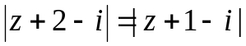 and
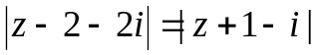
- Let 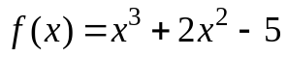 and 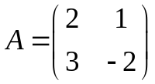. Compute det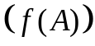.

- Let 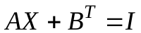, where 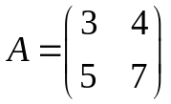, 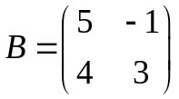, 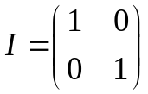. Find .

- Determine all real value(s) m, such that the matrix

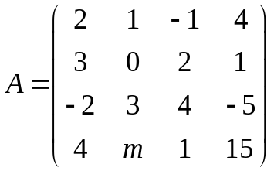 is invertible.

- Solve the following system of linear equations
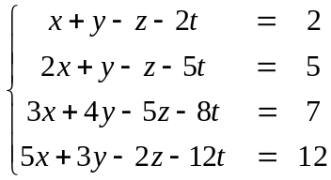

- Find all real values such that the linear system has a nonzero solution


  

